WHO ARE LACVS?
5 CVSs; 7 Volunteer Centres; 1 equality network; vision for 14 place based community networks (LOCAL – Locally Organised Communities Across Lancashire).
 |  |  | 
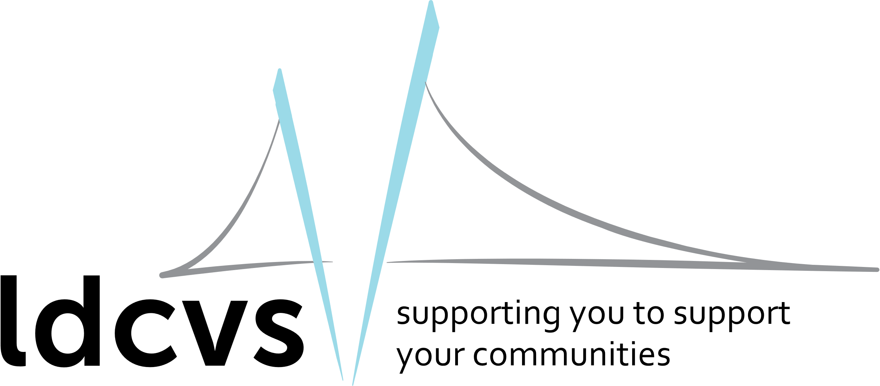 |  |  |  |  | 
 |  |  |  | 

ACHIEVEMENTS OF LACVS AGAINST THE VCFSE MANIFESTO
Lancashire LOCAL listened to and engaged with 3983 VCFSE organisations in 2023-2024, which was the 1st year of our Lottery project. We have a small team of 4 part-time staff. We hope to engage with more VCFSE organisations in the future!
Equality and Social Justice for All: Tackling Poverty in Lancashire |  | Green Communities | Pioneer a Lancashire Social Prescribing Model
Racial Justice: Inclusive North is leading the NW Phoenix Way programme.  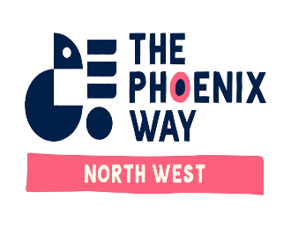  Need to take forward action on equalities and racial justice. | Tackling Poverty – focus of today’s conference  Need to take forward any actions from today on tackling poverty. | Helping to advocate for and develop Sustainable Food Places:  - Lancaster  - Blackburn with Darwen  - West Lancashire  …  Need to help the VCFSE Sector more to help our communities move to net zero. | Advocating for a VCFSE led model for social prescribing (based on what works in East Lancashire – grants, connectors, partnership working, etc.).  Awaiting outcome of the ICB’s Social Prescribing Review.  Need to support the Lancashire and South Cumbria VCFSE Alliance to ensure the VCFSE Sector is at the forefront of changes within the NHS as it works through its financial challenges.
Adequate VCFSE Resources |  | VCFSE Sector as an Equal Partner | Community Well-Being & Volunteering
- Fairer Funding Conference (July 24) – Blackpool  - New small grants programme for Fylde and Wyre (2024) and new LACVS / Local Fylde Coast VCFSE Support Fund to start in 2025.  - Lobbying for a Lancashire Funders Forum to take a more strategic approach to funding the VCFSE Sector in Lancashire. |  | - Respond to national consultation on Civil Society Covenant  - Will start to advocate for a Civil Society Board for Lancashire  - Support Lancashire and South Cumbria VCFSE Alliance to connect with the health system | - 1 of 15 partnerships nationally as part of the Volunteering for Health programme. Focus on health champions and improving the volunteer eco-system across Lancashire and South Cumbria.  - With the help of Preston City Council set up Preston Volunteers – a new volunteer centre for Preston.
Economic Model that works for Lancashire |  | Helping People into Employment | Safer Communities
- Advocate for VCFSE Sector involvement with the Lancashire Combined Authority and recognition within the Growth Strategy.  - Advocate for a Lancashire Civil Society Board to sit alongside the Business Board. |  | - Advocating for VCFSE Sector involvement in Work Well and the new employment programmes. | - Will be taken forward in future years

Looking Ahead
LACVS & Lancashire LOCAL priorities |  | Headlines of Change
- Leadership & Advocacy for the VCFSE Sector  - Take forward actions from the Conference  - State of the Sector Research (on behalf of the Lancashire and South Cumbria VCFSE Alliance) |  | Social Change  - Greater social inequalities; growing and ageing population; need for stronger more cohesive communities.
- Collaborations and Partnerships  - Aspiration for 14 place based VCFSE Networks. We know there are gaps but having local networks is crucial. |  | Technology Change  - Greater use of digital technology & a growing digital divide.
- Capacity Building: skills and capabilities  - Pilot neighbourhood approaches and grant programmes.  - Training and workforce development |  | Economic Change  - The economic model only works for the few. Too many are economically excluded. The cost of living crisis.
- Creating a vibrant volunteer eco-system  - Volunteering strategy; good practice development and training; voice of volunteering; new volunteering opportunities and brokerage. |  | Environmental Change  - The climate emergency is becoming more critical and we must do what we can to move towards net zero.
- Organisational Development within LACVS  - Improve how local infrastructure organisations work together to benefit the VCFSE sector. |  | Political Change  - New national Labour Government; New Lancashire Combined Authority; Likely Local Government Reform  - Local NHS system is ‘the most financially challenged nationally’.

