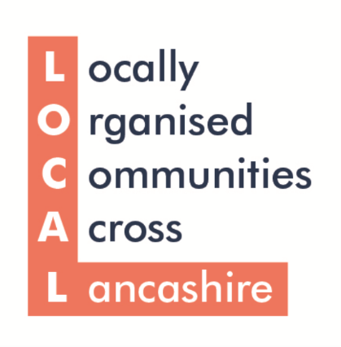

Lancashire LOCAL’s VCFSE Vision - Event Consultation Form

Important this is returned to vision@lancashirelocal.org by Friday 19th March (end of phase 1) so that the vision created at your event contributes to the overall shared vision produced at the end of the consultation.

Who are you?

Name:
Organisation:
Email address:
What region(s) in Greater Lancashire/ Lancashire 14 does your organisation or network cover?

How many people came to your event?

Who did they represent?
Please indicate organisation names, if applicable
Do you have any amendments to the 10 priority areas themselves?

Have we missed anything? What would be your 11th priority?

What of the 10 existing priority areas were most important to attendees at your event?

On the next page, please indicate what the key components of your vision for each area are.

You can complete as many or as few as you like.

Implement an Anti-poverty Strategy for Greater Lancashire
1.
2.
3.

Levelling Up: Secure national investment to build an economic model for all of Lancashire
1.
2.
3.

Grow sustainable, environmental communities
1.
2.
3.

Equality and Social Justice for All
1.
2.
3.

Harness the VCFSE role in inclusive local economies
1.
2.
3.

Develop the sector’s role in helping people into employment
1.
2.
3.

Build a social prescribing model for Lancashire
1.
2.
3.

Person and community-centred public service models
1.
2.
3.

Scale up VCFSE role in Building Safer Communities
1.
2.
3.

Adequately resource the VCFSE Sector
1.
2.
3.

